E-COMMUNICATION

Communication is an act or an instance of transmitting information using sounds, signs, behavior, verbally or in a written message to express your ideas, thoughts, feelings etc. Methods of communication date to prehistoric times with very primitive ways of communication but were very essential then, but since then communication has been evolving in tandem with shifts in the political and economical systems and because of that communication can range from very subtle processes of exchange of full conversations to mass communication.

Online communication can be achieved by using the internet to pass information to all parts of the world, some of the methods used to communicate over the internet are

* E-mail
* Instant messaging (IM)
* Newsgroups
* Online conferencing
* Blogs
* Social media
* Chat rooms etc.

1. **E-MAIL.**

This is the transfer of digital messages by electronic means from one computer user to one or more recipients. This was one of the most common types of communication from 1993. Some forms of the earlier email systems required both parties to be online to receive the message today’s system works on a store and forward model meaning that the information sent is kept and sent at a later time .

With Yahoo has become very popular and known for its web portal, search engine, Yahoo! Directory, Yahoo! Mail etc. It is also one of the highest read –news and media website with over 17 billion readers per month.



Some examples of email systems are:

* Gmail
* Yahoo
* AOL
* Outlook etc.



**Advantages**

* Emails don’t use paper making it very environmental friendly and save trees from being cut down.
* You can very easily attach files and folders that need to be sent urgently.
* Emails as well save money, it allows a company to reach customers, vendors business partners all over the world without spending money on postage.
* Emails can also be used for advertising, companies are able to reach out to their customers to inform them about new stock.
* Sending an email is very easy , it takes very little or no training on how to do this
* On top of that emails are free to send so there is no need for providing credit card details all one needs is an email address.
* Emails can be sent at any time and the recipient will be able to open it when they access their email account
* 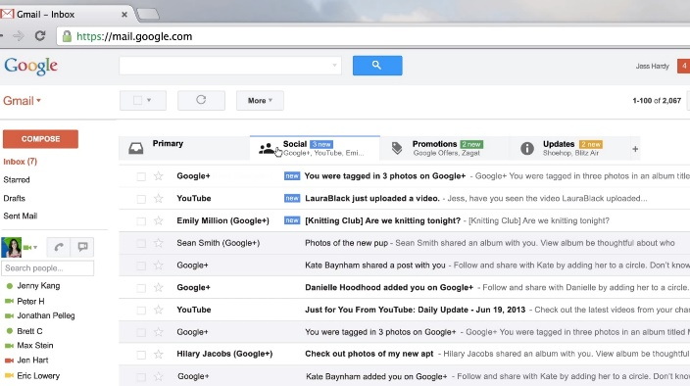The same message can be sent to more than one person
* Messages can be drafted and sent when they are ready
* Messages can also be encrypted so that it’s possible to send confidential information
* People don’t have to be present to receive an email.

**DISADVANTAGES**

* Some emails can carry some malicious software (viruses) that can harm your computer system and can also be used to go through your email address contacts and send the same to others.
* Many people don’t check their email very often causing them to send a late reply making it an inconvenience to the sender.
* Both participants should have an email address and access to a computer or any other device that can connect to the internet.
* There a lot of email scams that people get fooled by which is known as online phishing which is the provision of credit card details and other sensitive information to people that can be used for sabotage
* Some people send unwanted messages which are known as spam, it takes a long time to filter these messages from the important ones.
* Emails tend to be treated like a normal conversation when talking about a business by carrying it out with slang because emails don’t have any voice inflection and people don’t see each other eye to eye which don’t bring out the right interpretation.
* In an informal setting emails can lack a ‘personal touch’ giving it a very dull response.
* Checking the emails takes a lot of one’s time and making them seem antisocial when socializing with others.
* Some people send emails to friends and family during work hours making them spend a lot of time conversing with them



1. **INSTANT MESSAGING**

This is a type of online communication that enables you to kind of create a chat room with another individual or a group of people in order to communicate in real time. Analogous to a telephone conversation but this is a text-based communication system. Some of the more advanced IM applications can add file transfer, clickable hyperlinks, voiceover IP or even video chat. Typically the instant messaging systems alerts you when a message or when someone from your private list of contacts is online.

IM differs from email in the immediacy of the message exchange and also makes a continued exchange simpler than sending email back and forth.

Examples of IM applications are:

* Whatsapp
* Skype IM
* 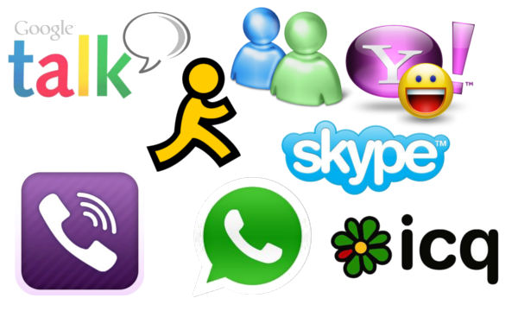Google talk
* Hangouts
* Meebo
* Nimbuzz
* Imo.im
* E buddy
* Pidgin
* Facebook chat
* Yahoo messenger. etc.
* Kik

**ADVANTAGES OF IM**

* Like email IM allows you to chat in real time to other people who also have an IM client but the immediacy of the message is faster than that of email.
* IM-ing can be very useful for customer support contact instead of having to phone a support line.
* The use of IM can also connect you with other people around the world and creating a friendship with them.
* With IM you have the ability to speak to multiple people online at the same time either through several IM windows or inviting people to a chat room.
* During work hours co-workers are able to send short messages in the workplace.
* People are able to keep in contact with family and friends when not in the same country or city.

**DISADVANATAGES OF IM**

* One disadvantage is the inability to gauge the emotional well-being through IM.
* There can also be uncertainty that the person you are talking to is the person you think it is , this can be very dangerous especially for teens as there’s no guarantee to knowing who or how old the person is.
* Possibility of getting viruses from files attached in the messages sent.
* As it is immediate you have no time to reflect on the message you are sending unlike an email where you can review a draft before sending it.
* In order to provide a free service the IM providers send adverts and popup windows to each person and the only way this can be avoided is by paying for a premium service.
* Again with if the IM settings are not configured properly then anyone can be able to send you a message which is not always the best because some children can give sensitive information e.g. house addresses and telephone numbers.
* There is a likelihood of miscommunication, because a screen separates people, some individuals may not feel the need to use the appropriate “netiquette” in terms of proper English grammar and the proper punctuation.
* In workplaces there are some security risks for example the content of the instant messages may be intercepted as a result sensitive data like customer lists and sales report may be revealed on the internet.
* Another big risk of IM is security, when you send a message to a friend there is the uncertainty of who the message is being viewed by.

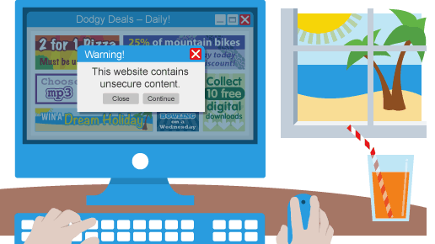

1. **NEWSGROUPS**

A newsgroups is a discussion about a particular subject consisting of notes written to a central internet site and redistributed through *UseNet* that mains an online discussion on a computer network. Despite the name newsgroups are discussion groups, and are not devoted to publishing news.

Usenet is a worldwide distributed discussion system, users read and post messages (called articles or posts) to one or more categories known as newsgroups.

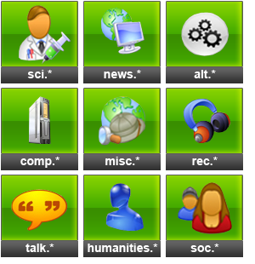Before the uptake of the World Wide Web, UseNet newsgroups were among the most popular internet services, and have retained their noncommercial nature in contrast to the increasingly ad-laden web. In recent years, this form of open discussion on the internet has lost considerable ground to individually-operated browser –accessible forums and social media networks.

**TYPES.**

News groups come in two types

1. **Binary**.

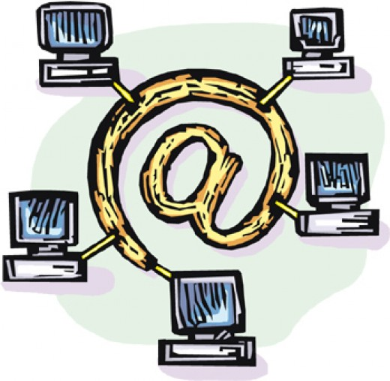Since newsgroups were not created with the intention to send files such as pictures, sound and video they have proven to be quite efficient.

1. **Text**

A moderate newsgroup has one or more individuals who must approve posts before they are published.



**Features of newsgroups**

1. *Group communications:* the UseNet is a powerful facilitator of group communication across time and geographic space. One person can post a message, another person reply to it, and another reply to it no matter where they are in the world.
2. *Common spaces:* The Usenet is the second largest common public space in existence, next to the [Internet](http://www.livinginternet.com/) itself. Anyone can post anything they wish to any newsgroup, and anyone can read any message they wish from any newsgroup.

**ADVANTAGES OF NEWSGROUPS**

Newsgroups are similar in some ways to mailing lists, but they tend to have a better structure, which makes it more likely that they will be around for much longer than a mailing list.

* You select which newsgroups you want to browse, "subscribe" to them, download a list of available messages and then double-click the entries you want to download. This is an excellent method to use when you want to browse a newsgroup. News Rover takes care of the details of getting multi-part messages with file attachments.
* Another advantage is that it offers, over a web gateway, is the ability to simultaneously scan several servers and several groups at one time, this allows you as the reader to download content at much higher speeds than can be obtained from a web gateway which is very helpful when downloading a large folder.
* You are also able to save a lot of time as it can be set to download all the files from your favourite newsgroups automatically.

**DISADVANTAGES OF NEWSGROUPS**

* Newsgroups are not as quick as an email or even a mailing list, the usually take a longer time for example a day or two before a response.
* Another disadvantage is that the information that someone posts might not be very accurate/true or might be bias with the information.
* One main disadvantage is that you might attract people who you wouldn’t give any time of day to for example children, which would be really worrying if children have access to these newsgroups.

**BLOGS**

A regularly updated website or web page, typically one run by an individual or small group that is written in an informal or conversational style. A majority are interactive, allowing visitors to leave comments and even message each other via GUI widgets on the blogs, and it is this interactivity that distinguishes them from other static websites. In that sense, blogging can be seen as a form of social networking service. Indeed, bloggers do not only produce content to post on their blogs, but also build social relations with their readers and other bloggers.

**FEATURES OF A BLOG**

* A blog has some form of navigation, usually menus
* A blog’s layout contains a header, footer and content, usually there is at least on sidebar running beside the content.
* There is a variety of categories to choose from (different genres)
* The posts can contain links to other posts

**ADVANTAGES OF BLOGS**

* Enables you to write down your thoughts on anything that interests you.
* Very quick and easy to setup, you don’t need that much technical knowledge.
* It Is very easy and quick to update or add new posts.
* Unlike any other jobs blogging does not take as much energy as other jobs do.
* For the full time bloggers they have enough time to write their blogs with no disruptions from places of work

**DISADVANTAGES OF A BLOG**

* Whatever you publish is available for everyone to see, if you write a post in anger you might regret it later.
* Personal blogs may be biased or contain inaccurate information.
* Blogs can be very time consuming especially for those who have jobs other than blogging.
* People may leave rude or inappropriate comments which may be hurtful.
* Feeling of loneliness when writing blogs because most bloggers write from home.
* When bloggers have other jobs other than blogging it is hard for them to keep up with both of them and to post

**VIDEO CONFERENCING**

This is the conduct of meetings by a set of telecommunication which allows two or more locations to communicate by simultaneous two-way video and audio transmissions. It is also known as “visual collaboration”. This differs from videophone calls in that it is designed to serve a conference or multiple locations rather than individuals.

**Advantages**

* You are able to save on money that could be used for travelling organizations had to find an alternative instead of paying large amounts of money for their employee’s to travel.
* You are able to communicate to any other office or individual around the world.
* Having a visual of the other person makes point to be passed across very clearly, there is no uncertainty of the other person’s emotion.
* Ideas and knowledge can be passed on to one another with an immediate response.
* Video conferencing is also another excellent way of keeping in touch with friends and family around the world.

**Disadvantages**

* Even with fast connectivity, there might be a slight delay between the responses.
* if there is any malfunction in any of the participants hardware they will not be able to attend the meeting
* There is no substitute for a face-face meting and getting to know someone on a personal level.
* One major disadvantage is that of different time zones which means that you will have to agree on a certain time of which might not suite your preference.